Final Report

The tech devils

Student names: Luuk Vogel/ Mitchell van ‘t Kruys/ Victor Florea/ David Horvath

Student Numbers: 3850560/ 4058151/ 3880346/ 3698009

Group: The Tech devils

Date: 01-16-2020

Table of Contents

Introduction 2

Project background 3

Project statement 4

Project Organization 4

Process & Results 5

System architecture (big picture/block diagram) 5

Wiring diagram (breadboard connections) 6

Door system 6

Livingroom 6

bedroom system 7

Kitchen system 7

Conclusion & recommendations 8

conclusion 8

Recommendations 8

Evaluations /Reflection 9

# Introduction

The student hotel is a project that provides students ambient and smart facilities while providing a pleasant stay and a study environment. The Student Ambient House is a new concept, which aims to allow students to work and live in an atmosphere that inspires them. The rooms provide the guests experience in an ambient environment. That means that the rooms have fully adaptive lighting, fully equipped rooms, kitchens (shared or private), chill-out lounges and so on. The guests will need to collect a digital key at the reception desk, which can be used to open different rooms (for example, guest room, or laundry room). The fully adaptive lighting, called mood lighting, can be setup for any occasion.

# Project background

Team 3, The Tech Devils, have been given the task to make the ambient and smart facilities a reality. Team 3 consists of 4 members, Mitchell van ‘t Kruys, who has taken the task of scrum master, Viktor Florea, David Horvath and Luuk Vogel, who have been given the task to make the system. Their mentor & tutor is Xuemei Pu and their technical advisor is Jaap Geurts. The team members are ICT student of Fontys ICT & Technology and have been given this task for their advanced project. The advanced project has a time limit of 6 weeks, in which each week, the team will have to present what they have accomplished during the week. This presentation is called a scrum meeting. The team will not only show their progress during this meeting, but also what their priorities and the obstacles they think they are going encounter.

The system has a few requirements it must meet. Since the concept is new, the team can give advice with new ideas and other concepts. The first requirements that needs to be met is a key system, which needs to have the following features, lock and unlock doors, register a guest and grant access to facilities and de-register a guest. The second requirement is a fully adaptive lighting system for the rooms. The lights need to turn on if a guest enters a room and turned off when no one is there. The third requirement is that the facilities need to have customized lighting, according to the setting the guest wants such as party lights, meeting lights, or study lights. The fourth and fifth requirements are that every room should have a smoke detector and an air conditioner (which will be simulated by, with a fan) and can be adjusted according to the temperature.

The system hardware consists of multiple Arduino Uno’s, a laptop that is used as an administrator application, various sensors and actuators, breadboard, resistors and wires. The system software is coded in a language called C sharp (C# for short). In order to write the code, 2 IDE’s (integrated development environment) are needed, called Arduino.cc and visual studio. The hardware and software will be combined in order to create a simulation of the ambient facilities.

# Project statement

|  |  |  |  |
| --- | --- | --- | --- |
| Project Name | Advanced Project | | |
| Mentor & tutor | Xeumei, Pu | **Technical advisor** | Jaap Geurts |
| Project start date | 2 December, 2019 | **Project end date** | 21 January, 2020 |
| Scope of project | In Scope:   * Smoke detector, to detect abnormalities in the room. * A Fridge system * Mood lighting system * Fan control system, to use as a * RFID system, a door system that grants access or * Administrator system to   Out of Scope:   * Internet access to the system * Curtain control * Washing machine control | | |
| Deliverables | Project deliverables:   * Project plan * System design * Product: the prototype * Final report | | |
| Criteria | The project will be accepted and graded by the mentors if the team’s systems and the deliverables meet the requirements. This project will be successful if the prototype is fully functional. | | |
| Constraints | The team has 6 weeks to complete this project. | | |

## Project Organization

# Process & Results

## System architecture (big picture/block diagram)

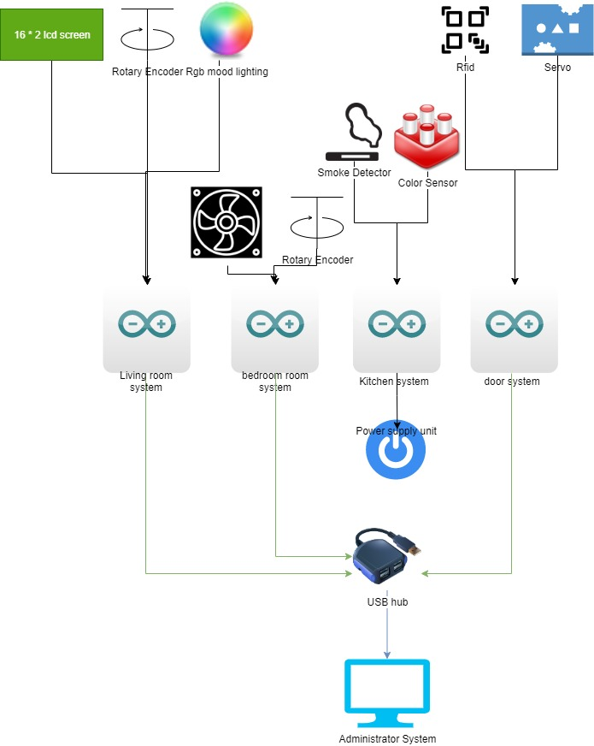

## Wiring diagram (breadboard connections)

### Door system

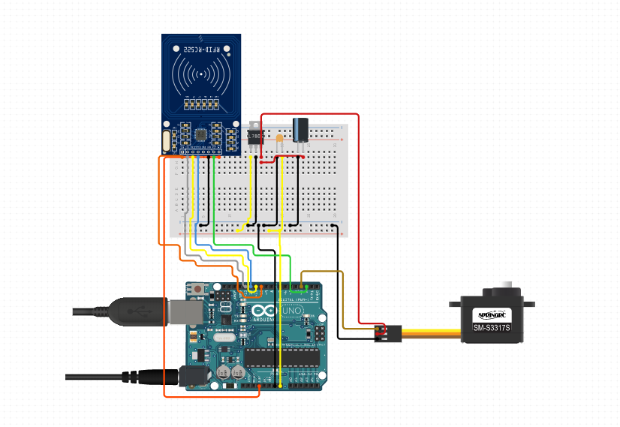

### Livingroom

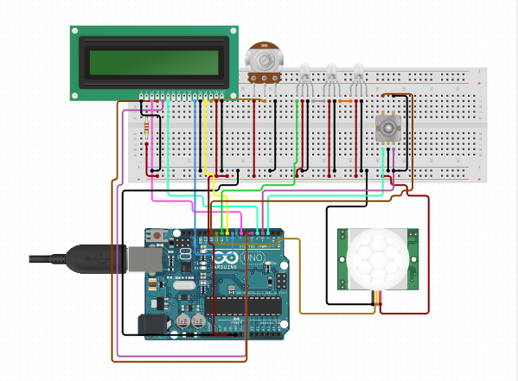

### bedroom system

### Kitchen system

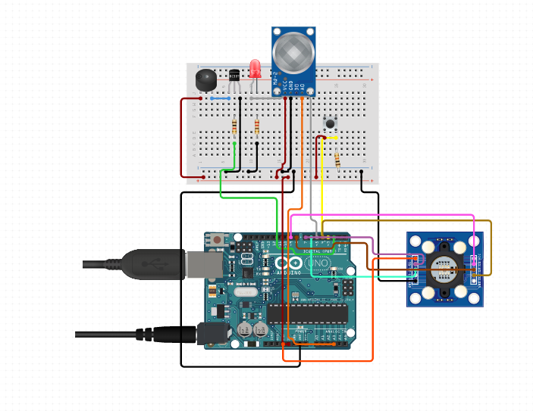

# Conclusion & recommendations

## conclusion

The student ambient house project is a very positive and solution to the student’s life. It encourages a healthy living situation for students who live far away from family or friends. IN conclusion, we The Tech Devils would recommend these facilities to any student, who has problems with living in stale conditions, which could be unhealthy to them.

## Recommendations

The student ambient house facilities are a recommendation for any student, who want to live in a healthy and study encouraging environment. The facilities are well equipped with the best technology for any student, who wants to not only study, but also for students who want to party in a safe place. The facilities are also well equipped with healthy food and multiple facilities to keep all anyone in shape, if they choose to.

# Evaluations /Reflection

#### **Luuk Vogel**

I think what we delivered was pretty good but if we had better communication and planning, we could have achieved a little more. We started of good keeping to the schedule and having good communication but after the holidays I think the motivation died out a little, so we started to slack a little. But the last week we worked hard to put everything together and I think the result is pretty good.

Personally, I think I could’ve worked a little harder myself too especially during the holidays, but I planned a little too many other things to do. I also think I could have maybe asked more questions to my project group about things I didn’t understand because the team was good at explaining things to others. Overall, I have to say, because we didn’t really know each other before the project, we did well.

#### **Mitchell van ‘t Kruys**

This project has been very educational both technical and non-technical. On the technical side, I have learned a lot such as protocols and different ways of programming. I have learned on the non-technical side, to plan a little bit better, and how a scrum master, goes about managing a team and what he must pay attention to. As a group I have learned to work with people that I do not fully know. I learned that it is very important to listen to each other and ask for help when needed. I have also learned the great importance of proper communication and planning. Even though this time it did not go as smooth as it could have been, in my experience it went better than I previously have come across. As a team in the first few weeks we worked very hard and produced good work. Later in the semester towards vacation, our team motivation went down quite a bit, probably because of the vacation we have longed for.

What could have gone better is communicating and planning. Communication is essential for everyone in the group to be up to date and make plans accordingly. If something for example goes wrong or someone does not deliver something they had hoped to deliver, with clear and on time communication, this issue can be negated, or the person might receive help form the rest of the team members.

#### **David Horvath**

The project started out well despite me joining the team after the kickoff. I feel like everyone had good ideas and contributions to the overall project and this allowed us to go beyond the required deliverables and come up with our own additional features to the system, even if some of them were not fully realized in the end. Aside from a few pacing issues, the teamwork was solid, and the tasks were nicely divided, so I rate this project five out of five.

#### **Viktor Florea**

Even though we did not know each other before The Project Phase we started to get things done quick and help each other whenever we needed. I personally think that these two months were interesting because my team bonded in this time and we also delivered a good project. I also learned a lot from this project, such as coding protocols and how communications between the systems work.